ATTACHMENT 2 – RECOMMENDED CONDITIONS OF CONSENT

Council has imposed the following conditions under the relevant planning instruments and policies.

PART 1:

DEFERRED COMMENCEMENT

Development consent shall be deferred pursuant to Section 4.16(3) of the Environmental Planning and Assessment Act 1979, until the submission to Council of:

Civil Engineering

- The following plans/reports, outlined in Table 1 and 2 of this deferred commencement condition, shall be revised to the satisfaction of the Consent authority prior to the issue of an operational consent.

Table 1: Plans

Plan Name | Drawing No. | Revision | Date | Prepared by
Ground Floor Stormwater and Details | 21337-004 | C | 11/12/2019 | EWFW Consulting Engineers
Ground Floor Stormwater and Details | 21337-015 | E | 9/12/2019 | EWFW Consulting Engineers
OSD Tank Details | 21337-016 | C | 12/6/2019 | EWFW Consulting Engineers
Water Quality Tank Details | 21337-017 | A | 2/10/2019 | EWFW Consulting Engineers
Kerb and Footpath Typical Details | 21337-020 | B | 8/11/2018 | EWFW Consulting Engineers
Typical Drainage Lintel Gutters | 21337-021 | B | 8/11/2018 | EWFW Consulting Engineers

Table 2: Reports

Plan Name | Revision | Date | Prepared by
Stormwater Design Summary Report | C | 13/11/2018 | EWFW Consulting Engineers

The above documentation as well as the submitted electronic DRAINS model shall be revised to address the following matters to Council’s satisfaction:

- The OSD Tank shall be redesigned to ensure the following:
  - OSD Tank shall be accessible from the street;
  - In the event that the outlet is blocked or the maximum water storage has been exceeded, the tank will surcharge out onto level 1. A satisfactory emergency overflow path to the street is required;
  - Minimum freeboard to non-habitable spaces shall been complied with.

- Limit scope of the DRAINS model to include only areas relevant to the proposed development site. There are currently too many warnings i.e. potential issues noted within the model;

- Provide RL of OSD access grate;

- DRAINS model is to be consistent with the submitted stormwater drainage plans;

- Provide concept road and drainage design of the rear laneway. The concept shall demonstrate how the upstream catchment is to be captured and conveyed to the downstream discharge point.

- Provide engineering detailed design of the proposed North to South shareway. The design shall ensure that the dimensions of the proposed shareway are adequate to enable one-way movement of vehicles to Elizabeth Street, drop off and pick up of passengers as well as pedestrian movement. Plans shall be coordinated with the approved Landscape Plan to ensure integration of public space improvements and its requirements are incorporated.

- Provide detailed engineering design for the rear service laneway from its junction with Bigge Street (to the east) through to its junction with George Street (to the west). The laneway shall be designed at a stratum level agreed to by Council’s Asset Section. Written owner’s consent shall be obtained from adjoining owners for the submitted engineering design.

Note: The items raised within Part 1, above, are to be addressed within five (5) years of the date shown on Council’s determination notice. The consent shall become operative once Council has notified the applicant in writing that the evidence submitted in response to the “Deferred Commencement” conditions is acceptable.

PART 2

On the submission of the required evidence and on the applicant receiving written notification that Council is satisfied that the matters listed in “Part 1” have been satisfied, then the consent shall become operative subject to compliance with conditions outlined in “Part 2”.

A. THE DEVELOPMENT

Approved Plans

- Development the subject of this determination notice must be carried out strictly in accordance with the accompanying plans and reports listed below and stamped DA-886/2018, except where modified by the undermentioned conditions:

- Plans:
Plan Name | Plan Number | Date | Issue | Prepared By
Architectural Plans
Site Dedication Plan | TP00.05 | 11.05.20 | C | rothelowman
Constraints Plan and Section | TP00.06 | 11.05.20 | B | rothelowman
Basix Commitments | TP00.07 | 11.05.20 | B | rothelowman
Basement 4 Plan | TP01.00 | 11.05.20 | M | rothelowman
Basement 3 Plan | TP01.01 | 11.05.20 | M | rothelowman
Basement 2 Plan | TP01.02 | 11.05.20 | M | rothelowman
Basement 1 Plan | TP01.03 | 11.05.20 | M | rothelowman
Ground Plan | TP01.04 | 11.05.20 | N | rothelowman
Level 1 Plan | TP01.05 | 11.05.20 | M | rothelowman
Level 2,3 & 4 Plan | TP01.06, TP01.07, TP01.08 | 11.05.20 | L | rothelowman
Level 5 Plan | TP01.09, | 29.01.20 | L
Level 6,7 & 8 Plan | TP01.10  TP01.11  TP01.12 | 29.01.20 | K | rothelowman
Level 9 Plan | TP01.13 | 29.01.20 | K | rothelowman
Level 10 | TP01.14 | 29.01.20 | K
Level 15,  Level 20 & 25 Plan | TP01.16 | 29.01.20 | K | rothelowman
Levels 11 to 14  Levels 16 to 19  Levels 21-24 & Levels 26-29 Plans | TP01.15 | 29.01.20 | K | rothelowman
Levels 30 to 32 Plans | TP01.18 | 29.01.20 | K | rothelowman
Level 33 Plan | TP01.40 | 29.01.20 | L | rothelowman
Roof Plan | TP01.41 | 29.01.20 | K | rothelowman
Ground Floor Mezzanine | TP01.50 | 29.01.20 | C | rothelowman
North Elevation | TP02.01 | 29.01.20 | E | rothelowman
South Elevation | TP02.02 | 29.01.20 | E | rothelowman
East Elevation | TP02.03 | 29.01.20 | E | rothelowman
West Elevation | TP02.04 | 29.01.20 | E | rothelowman
Section 1 | TP03.01 | 29.01.20 | K | rothelowman
Section 2 | TP03.02 | 29.01.20 | G | rothelowman
Section 3,4 &5 | TP03.10 | 29.01.20 | H | rothelowman
Ramp Sections | TP03.12 | 29.01.20 | F | rothelowman
Communal Open Space Plans | TP06.04 | 29.01.20 | C | rothelowman
Storage Plan | TP06.20 | 29.01.20 | D | rothelowman
Landscape Plans
Landscape Cover Sheet | L-001 | 18.03.20 | A | Site Image
Landscape Composite Render | L-100 | 17.03.20 | A | Site Image
Landscape Plan – Ground Floor | L-101 | 18.03.20 | A | Site Image
Landscape Plan – Level 2 | L-102 | 18.03.20 | A | Site Image
Landscape Plan – Level 3 | L-103 | 18.03.20 | A | Site Image
Landscape Plan – Level 4 | L-104 | 18.03.20 | A | Site Image
Landscape Plan – Level 5 | L-105 | 18.03.20 | A | Site Image
Landscape Plan – Level 9 | L-106 | 18.03.20 | A | Site Image
Landscape Specification Notes | L-500 | 18.03.20 | A | Site Image
Landscape Details | L-501 | 18.03.20 | A | Site Image
Landscape Green Wall Details | L-502 | 18.03.20 | A | Site Image
Irrigation Specification | L-400A | 21.05.20 | A | Site Image

- Reports
Report name | Date | Reference | Prepared by
Architectural Report | 11/2018 |  | rothelowman
Aboriginal and Historical Due Diligence Assessment | 10/2/20 | P0017582 | Urbis
Access Report & Acoustic Statement | 9/11/18 | AAC-818 | Iaccess consultants
Acoustic Report | 11/09/18 | 2888/do3 | Sebastian Giglio
Acoustic Report Addendum | 14/6/19 | 2888/do5 | Sebastian Giglio
Acid Sulfate Assessment | 28.05/18 | E23796.E14_Rev0 | eiaustralia
Aviation Assessment Report | 6.11.18 | - | Thomson GCS
Basix Certificate | 8/11/18 | 961335M | Buillding & Energy Consultants
BCA Report | 5/11/18 | 8291 Rev3 | AED Group
Detailed Site Investigation Report | 9/11/18 | E23796.E02_Rev1 | eiaustralia
Contamination Report Addendum | 7/09/19 | E23796 | eiaustralia
Building Services Report | 30/04/18 | 21337.001B | EWFW
Fire Engineering Report | 13/11/20 | 18306_L01a | Innova services
Heritage Impact Statment | Nov. 2019 | _ | GBA Heritage
Landscape Design Report | 11.05.20 | SS20 4354 | Site Image
Wind Engineering Report | September 2019 | CPP Project 12575 | Cermack Peterka Petersen
Remedial Action Plan | 9/11/18 | E23796.E06_Rev1 | eiaustralia
SEPP 65 Statement | 14/11/18 | 218004 | rothelowman
Social Impact Assessment | 31.10.19 | P9360 | Urbis
Traffic Impact Assessment | 9/11/18 | - | ptc
Vertical Transport | 26/07/18 | - | Schindler
Operational 28Waste Management Plan | 10/02/20 | 17116 E | Elephants Foot

Works at no cost to Council

- All roadworks, drainage works and dedications, required to effect the consented development shall be undertaken at no cost to Liverpool City Council.

Fire Safety – Cladding

3. For all Buildings of Type A and B construction having finishes or claddings other than concrete or masonry, a fire safety report prepared by an accredited C10 fire engineer, must be submitted to the Principal Certifying Authority prior to issue of a construction certificate, demonstrating that the proposed external wall cladding material and system for the building complies with the NCC and relevant Australian Standards. The fire safety report is to include evidence of suitability of all proposed external wall cladding materials as per clause A2.2 of the NCC.

Requirements of Sydney Water

- The comments provided by Sydney Water shall be complied with prior, during and at the completion of construction, as required in accordance with their correspondence dated 2 May 2019. A copy of their correspondence is found as an Attachment to this decision notice.

Requirements of Endeavour Energy

- The comments provided by Endeavour Energy shall be complied with prior, during and at the completion of construction, as required in accordance with their correspondence found as an Attachment to this decision notice.

Requirements of the Department of Infrastructure, Transport, Cities and Regional Development

- The comments provided by the Department of Infrastructure, Transport, Cities and Regional Development in regards to the construction of the building and crane operation, shall be complied with prior, during and at the completion of construction, as required in accordance with their correspondence dated 18 July 2019. A copy of the correspondence is found as an Attachment to this decision notice.

Compliance with the Environmental Planning & Assessment Act 1979

- The requirements and provisions of the Environmental Planning & Assessment Act 1979 and Environmental Planning & Assessment Regulation 2000, must be fully complied with at all times.
Failure to comply with these legislative requirements is an offence and may result in the commencement of legal proceedings, issuing of ‘on-the-spot’ penalty infringements or service of a notice and order by Council.

Section 7.12 Payment (Liverpool Contributions Plan 2018 Liverpool City Centre)

- As a consequence of this development, Council has identified an increased demand for public amenities and public services. The following payment represents 3% of the cost of the development and is imposed in accordance with Liverpool Contributions Plan 2018 Liverpool City Centre.
The total contribution is $3,221,117 and will be adjusted at the time of payment in accordance with the contributions plan.
A breakdown of the contributions payable is provided in the attached payment form.
The Contributions Plan may be inspected online at www.liverpool.nsw.gov.au
Payment must be accompanied by the attached form.

In response to Covid-19, Council is providing for deferred payment options, for applications lodged or approved between 16 April 2020 and 31 December 2020. These provide for a deferral of 50% of the contribution amount to the occupation certificate stage. Please contact Council to discuss these options.

Stormwater

- Requirements for Sydney Water’s stormwater assets (for certain types of development) may apply to this site. The proponent should ensure that satisfactory steps/measures been taken to protect existing stormwater assets, such as avoiding building over and/or adjacent to stormwater assets and building bridges over stormwater assets.

- The proponent should consider taking measures to minimise or eliminate potential flooding, degradation of water quality, and avoid adverse impacts on any heritage items, and create pipeline easements where required.

B. PRIOR TO ISSUE OF A CONSTRUCTION CERTIFICATE

The following conditions shall be complied with prior to issue of a CC by the PCA:

Waste

- A waste matrices/tables shall be prepared detailing the different types and volumes/weights of materials that will arise from the excavation and construction phases of the development. These are to include whether these materials will be re-used, recycled or disposed of and the facilities to which those materials will be taken. The waste matrices/table shall be submitted to Council’s Manager of Development Assessment for review and endorsement.

Wind study

- Prior to the issue of a Construction Certificate, a detailed wind study with the results of modelling shall be prepared for the development and is required to verify that the design, as proposed, will meet the required ground level wind criteria. The wind modelling shall be submitted to Council’s Manager of Development Assessment for review and endorsement.

Fee Payments

- Unless otherwise prescribed by this consent, all relevant fees or charges must be paid. Where Council does not collect these payments, copies of receipts must be provided. For the calculation of payments such as Long Service Levy, the payment must be based on the value specified with the Development Application/Construction Certificate.

The following fees are applicable and payable:

- Damage Inspection Fee – relevant where the cost of building work is $20,000 or more, or a swimming pool is to be excavated by machinery,
- Fee associated with Application for Permit to Carry Out Work Within a Road, Park and Drainage Reserve, and
- Long Service Levy payment is applicable on building work having a value of $25,000 or more, at the rate of 0.35% of the cost of the works. The required Long Service Levy payment, under the Building and Construction Industry Long Service Payments Act 1986, is to be forwarded to the Long Service Levy Corporation or the Council, prior to the issuing of a Construction Certificate, in accordance with Section 6.8 of the Environmental Planning & Assessment Act 1979.

These fees are reviewed annually and will be calculated accordingly.

Compliance with the National Construction Code

- In accordance with section 4.17 of the Environmental Planning & Assessment Act 1979 and clause 98 of the Environmental Planning & Assessment Regulation 2000, it is a prescribed condition that all building work must be carried out in accordance with the applicable Performance Requirements of the National Construction Code. Compliance with the Performance Requirements can only be achieved by:

(a) Complying with the Deemed to Satisfy Provisions; or
(b) Formulating an Alternative Solution, which complies with the Performance Requirements or is shown to be at least equivalent to the Deemed to Satisfy Provision, or a combination of (a) and (b).

- Access must be provided to the building for people with a disability in accordance with the relevant requirements of the Building Code of Australia, Disability (access to Premises – Buildings) Standard 2010 and Australian Standard – AS1428.1 (2009), Design for Access and Mobility – General requirements for new building work, to the satisfaction of the Certifying Authority.

- A fire safety report prepared by an accredited C10 fire engineer, must be submitted to the PCA prior to issue of construction certificate, demonstrating that all proposed external wall cladding materials used for the building complies with the NCC and relevant Australian Standards. The fire safety report is to include evidence of suitability of all proposed external wall cladding materials as per clause A2.2 of the NCC.

- A schedule specifying all of the essential fire safety services, both existing and proposed, which are required for the building, shall be attached to the CC and submitted to Council, in compliance with the provisions of the EP&A Regulation.

The schedule must distinguish between the measures that are currently implemented in the building premises; and

(a) The measures that are to be proposed to be implemented in the building premises;
and
(b) The minimum standard of performance for each measure.

- No building products that are banned, or products that are subject to a ban if used in a particular way under the Building Products (Safety) Act 2017 are to be used in the construction of the development.

Provision of Services

- The developer should lodge a feasibility application with Sydney Water via a Water Servicing Coordinator (WSC) detailing concept water and wastewater servicing options.

- An application to obtain a Section 73 Compliance Certificate under the Sydney Water Act 1994, must be lodged with Sydney Water. To facilitate this, an application must be made through an authorised Water Servicing Coordinator. Please refer to the “building and developing” section of Sydney Water’s web site at www.sydneywater.com.au, or telephone 13 20 92.

Following receipt of the application, a ‘Notice of Requirements’ will detail water and sewer extensions to be built and charges to be paid. Please make early contact with the Coordinator, since building of water/sewer extensions can be time consuming and may impact on other services and building, driveway or landscape design. A copy of the ‘Notice of Requirements’ must be submitted to the PCA.

- Written clearance from Endeavour Energy, stating that electrical services have been made available to the development or that arrangements have been entered into for the provision of services to the development must be submitted to the PCA.

- Prior to the issue of a Construction Certificate, the Principal Certifying Authority shall be satisfied that telecommunications infrastructure may be installed to service the premises which complies with the following:

- The requirements of the Telecommunications Act 1997;
- For a fibre ready facility, the NBN Co’s standard specifications current at the time of
- installation; and
- For a line that is to connect a lot to telecommunications infrastructure external to the premises, the line shall be located underground.

Unless otherwise stipulated by telecommunications legislation at the time of construction, the development must be provided with all necessary pits and pipes, and conduits to accommodate the future connection of optic fibre technology telecommunications.

Design Verification Statement

- In accordance with the EP&A Regulation and State Environmental Planning Policy (SEPP) 65 “Design Quality of Residential Apartment Development”, the subject development must be undertaken or directed by a ‘qualified designer’ (i.e., a registered architect under the Architects Act). In this regard, a design verification statement shall be submitted to the PCA. The PCA shall ensure that the statement prepared by the qualified designer provides the following:

(a) A valid and current architect’s registration number (as issued by the NSW Architects Registration Board);
(b) That the qualified designer has designed or directed the design of the subject development; and
(c) That the plans and specifications lodged with the CC achieve or improve the design quality of the development for which the subject development consent was granted, having regard to the design principles set out in Part 2 of SEPP 65.

Note: The design verification statement must provide an explanation of the design in terms of the design quality principles set out in Part 2 of SEPP 65.

Recommendations of Acoustic Report

- The recommendations provided in the approved acoustic report 26 Elizabeth Street, Liverpool – Development Application Acoustic Report (Ref: 2888/D03) prepared by Sebastian Giglio dated 11 September 2018 and subsequent additional information titled Re: DA86/028, 26 Elizabeth Street, Liverpool – Response to Council’s Acoustic Queries dated 19 March 2019 (Ref: 2888-D05) prepared by Sabastian Giglio dated 14 June 2019 are to be implemented and incorporated into the design and construction of the development and be shown on plans accompanying the Construction Certificate application.

The construction methodology and plans accompanying the Construction Certificate application and mechanical plants and equipment shall be assessed and certified in writing by a suitably qualified acoustic consultant to verify conformance with the requirements of the aforementioned acoustic report. The written certification from the suitably qualified acoustic consultant shall be submitted to and approved by the PCA prior to the Construction Certificate being issued.

Note: ‘Suitably qualified acoustic consultant’ means a consultant who possesses Australian Acoustical Society membership or are employed by an Association of Australasian Acoustical Consultants (AAAC) member firm.

Construction Noise and Vibration Management Plan (CNVMP)

- A Construction Noise and Vibration Management Plan is to be prepared by a suitably qualified acoustic consultant in accordance with relevant planning policies, guidelines and standards (whether that be Australian, British or German) and is to include, but not be limited to, the following:

  - Site description
  - Nature of the development
  - Staging of construction
  - Hours of construction
  - A quantitative assessment of the airborne and ground-borne noise generated by the work for the proposed development and its impact on nearby receivers
  - A quantitative vibration assessment and the impact to surrounding structures and on nearby receivers
  - Proposed methods to mitigate the noise and vibration impact during the construction works
  - Complaints handling and community liaison procedures. This is to include but not be limited to a complaints register with complainant details, date and time of complaint, nature of complaint and how the complaint was resolved or handled.

Once the noise and vibration impact on the surrounding community and structures is adequately assessed, all necessary action is to be taken to eliminate such impacts as recommended and suggested by the suitably qualified acoustic consultant.

Construction Environmental Management Plan (CEMP)

- Prior to issue of a construction certificate, a Construction Environmental Management Plan (CEMP) for the development must be provided to the Principal Certifying Authority for approval. The environmental site management measures must remain in place and be maintained throughout the period of the development. The CEMP must address all environmental aspects of the development’s construction phases, and include (where relevant), but not be limited to, the following:

- Asbestos Management Plan;
- Project Contact Information;
- Site Security Details;
- Timing and Sequencing Information;
- Site Soil and Water Management Plan;
- Dust Control Plan;
- Air Monitoring;
- Odour Control Plan;
- Health and Safety Plan;
- Waste Management Plan;
- Incident management Contingency; and
- Unexpected Finds Protocol.

The CEMP must be kept on site for the duration of the works and must be made available to Council Officers upon request.

S138 Roads Act – Minor Works in the public road

- Prior to the issue of a Construction Certificate, a Section 138 Roads Act application/s, including payment of fees, shall be lodged with Liverpool City Council, as the Roads Authority for any works required in a public road. These works may include but are not limited to:
- Vehicular crossings (including kerb reinstatement of redundant vehicular crossings),
- Road opening for utilities and stormwater (including stormwater connection to Council infrastructure), or
- Road occupancy or road closures.
All works shall be carried out in accordance with the Roads Act approval, the development consent including the stamped approved plans, and Liverpool City Council’s.

Liverpool CBD – Street Lighting Upgrade

- The applicant/developer shall upgrade street lighting system for entire frontage of the development including any side streets. The street light pole shall be multi-function pole including all necessary accessories. The specification and accessories details are to be obtained from Infrastructure and Environment Group of Council. The applicant/developer shall engage services of Endeavour Energy accredited ASP Level 3 service provider to prepare electrical design and obtain certification from Endeavour Energy. The electrical design shall include undergrounding of existing aerial power lines and communication cables for entire frontage of the development including frontage to side streets. The approved design shall be submitted to Council for review and approval prior to any public domain construction works.

Liverpool CBD – Communication Conduits

- The applicant/developer shall also supply and install two 50mm white communication conduit with draw wires approximately 300mm behind kerb and gutter connecting multifunction poles. Details can be obtained from Infrastructure and Environment Group of Council. Please contact the Coordinator – Roads and Transport on 1300 36 2170.

Liverpool CBD – Footpath Paving and Landscaping Works

- Periphery Type/ Core Type paving shall be installed along the entire Elizabeth Street, frontages, as part of this development. Footpath paving and Landscaping works shall be strictly in accordance with the Liverpool CBD Street Tree and Landscape Strategy 2005 and The Liverpool CBD Streetscape and Paving Guidelines 2005 as amended in Implementation Note 12/2015 – Liverpool CBD Paving

Detailed plans are required to be submitted to and approved by Council showing the proposed tree locations, species and planting sizes, paving location and layout, including references to the relevant details and specifications as contained in the abovementioned documents.

To ensure that the street tree planting size, quantity and quality is maintained throughout the Liverpool CBD, please contact Council’s Land Development Section on 1300 36 2170 for further information.

A Section 138 Roads Act Approval for all works within Council’s road reserve will be required.

Retaining Walls on Boundary

- All retaining walls shall be of masonry construction and must be wholly within the property boundary, including footings and agricultural drainage lines. Construction of retaining walls or associated drainage works along common boundaries shall not compromise the structural integrity of any existing structures.
Where a retaining wall exceeds 600mm in height, the wall shall be designed by a practicing structural engineer and a construction certificate must be obtained prior to commencement of works on the retaining wall.
S138 Roads Act – roadworks requiring approval of civil drawings

- Prior to the issue of a Construction Certificate for building or subdivision works the Certifying Authority shall ensure that a S138 Roads Act application, including the payment of application and inspection fees, has been lodged with Liverpool City Council (being the Roads Authority under the Roads Act), for provision of CBD footpath paving and connection of stormwater) in the road reserve.
Engineering plans are to be prepared in accordance with the development consent, Liverpool City Council’s Design Guidelines and Construction Specification for Civil Works, Austroad Guidelines and best engineering practice.
Note: Where Liverpool City Council is the Certifying Authority for the development the Roads Act approval for the above works may be issued concurrently with the Construction Certificate.
Stormwater Concept Plan
- A stormwater drainage system shall be provided generally in accordance with the concept plan/s lodged for development approval, prepared by EWFW Consulting Engineers (as revised and submitted to Council in satisfaction of deferred commencement condition 1).
- The proposed development and stormwater drainage system shall be designed to ensure that stormwater runoff from upstream properties is conveyed through the site without adverse impact on the development or adjoining properties.
- Engineering plans and supporting calculations for the stormwater drainage system are to be prepared by a suitably qualified engineer and shall accompany the application for a Construction Certificate. The plan shall indicate the method of disposal of all stormwater and must include rainwater tanks, existing ground levels, finish surface levels and sizes of all pipes.
- Prior to the issue of a Construction Certificate the Certifying Authority shall ensure that the stormwater drainage system has been designed in accordance with Liverpool City Council’s Design Guidelines and Construction Specification for Civil Works.
Stormwater Discharge – Basement Car parks

- Prior to the issue of a Construction Certificate the Certifying Authority shall ensure that the stormwater drainage system for the basement car park has been designed in accordance with the requirements for pumped systems in AS3500.3:2003 and Council’s Stormwater Drainage Design Specifications for pump out systems for basement carparks.

Water Quality

- Prior to the issue of a Construction Certificate, the Certifying Authority shall ensure that details of a stormwater pre-treatment system have been provided on the stormwater plans and that the design meets pollutant retention criteria in accordance Council’s Development Control Plan.
The Construction Certificate must be supported by:
- Specification & installation details of the stormwater pre-treatment system
- The approval of an operation and maintenance manual/ schedule for the stormwater pre-treatment system
A copy of the approved operation and maintenance manual/ schedule shall be submitted to Liverpool City Council with notification of the Construction Certificate issue.
Peer Review of Geotechnical Report

- An independent peer review of the geotechnical report and future structural design of the development will be required at no cost to Council. The peer review shall be submitted to the Principal Certifying Authority for approval. This is to ensure that there are no impacts to the existing embankment at the rear of the property within the Council reserve.

Traffic

- Detailed design drawings of the laneway, driveways, speed hump, ramps, aisles, loading bays, parking spaces, and boom gate demonstrating that the design has been carried out in accordance with RMS Guidelines, DCP and AS: 2890 is to be submitted to Council for review and endorsement prior to Construction Certificate. The design needs to be accompanied by a certification from a qualified independent traffic engineer that the design drawings comply with the requirements of Liverpool Council DCP and Australian Standard. It needs to include the following:

- The proposed laneway, driveways, ramps, aisles, loading bay and parking spaces,
- Swept path analysis
- Footpath paving on all streets fronting the development in accordance with Council requirements
- Sign and line marking scheme
- Boom gate and speed hump associated with the Elizabeth Street exit driveway. The speed hump is to be located between the boom gate and the footpath along Elizabeth Street. The driveway is to be designed to ensure vehicles can only turn left to Elizabeth Street.
- Median strip on Bigge Street facing the intersection of Bigge Street and the proposed laneway to prohibit right turn movements to and from the laneway onto Bigge Street.

- Submision of a signs and linemarking scheme, including ‘No Stopping’ restrictions along the proposed laneway, and the median strip on Bigge Street to Council’s Traffic and Transport Section for Liverpool Local Traffic Committee’s approval prior to installation.

- An Endeavour Energy accredited ASP Level 3 service provider is to be engaged to prepare electrical design for upgrading of the existing street including undergrounding of existing aerial power lines (where required) and communication cables for entire development site frontages including side streets, in accordance with Council’s and Endeavour Energy specifications.

The upgrade is to include replacement of the existing street columns with Council approved multi-function poles (MFP) including all necessary accessories. Specification and accessories details of the MFPs are to be obtained from Council’s Infrastructure and Environment Section.

Traffic Management Plans

- A Construction Traffic Management Plan (CTMP) detailing construction vehicle routes, number of trucks, hours of operation, access arrangements and traffic control, if any, is to be submitted to Council for review prior to the issue of CC.

- A traffic management plan is to be submitted to Liverpool City Council’s Traffic & Transport Section for approval by Council's Traffic Committee. Works within the road reserve shall not commence until the traffic management plan has been approved.

The traffic management plan is to be prepared by an accredited designer and submitted to and stamp approved by Council via a standard Section 138 Roads Act Permit application available at Council’s customer service counter. The stamped approved Roads Act Permit is to be obtained by the PCA. A copy of the stamped approved Roads Act Permit and traffic management plan is to be available on the works site for inspection at any time by an authorised Council officer.

Access, Car Parking and Manoeuvring - General

- Prior to the issue of a Construction Certificate the Certifying Authority shall ensure that vehicular access, circulation, manoeuvring, pedestrian and parking areas associated with the subject development are in accordance with AS 2890.1, AS2890.2, AS2890.6 and Liverpool City Council’s Development Control Plan.

Dilapidation Report

- Prior to the Commencement of Works a dilapidation report of all infrastructure fronting the development in Elizabeth Street is to be submitted to Liverpool City Council. The report is to include, but not limited to, the road pavement, kerb and gutter, footpath, services and street trees and is to extend 20m either side of the development.

Dilapidation Report Private Property (Excavations)
- A full dilapidation survey and report on the visible and structural condition of all neighbouring structures within the ‘zone of influence’ of the required excavations must be submitted to the Certifying Authority for approval prior to the issue of any Construction Certificate. The zone of influence is to be defined as the horizontal distance from the edge of the excavation face to twice the excavation depth.
The dilapidation report and survey is to be prepared by a consulting structural/geotechnical engineer agreed to by both the applicant and the owner of any affected adjoining property.
All costs incurred in achieving compliance with this condition shall be borne by the person entitled to act on this Consent.
In the event that access for undertaking the dilapidation survey is denied by an adjoining owner, the applicant MUST DEMONSTRATE, in writing, to the satisfaction of Council that all reasonable steps have been taken to obtain access and advise the affected property owner of the reason for the survey and that these steps have failed. Written concurrence must be obtained from Council in such circumstances.
Note: This documentation is for record keeping purposes only, and may be used by the developer or affected property owner to assist in any action required to resolve any dispute over damage to adjoining properties arising from the works. It is in the applicant’s and adjoining owner’s interest for it to be as full and detailed as possible

Heritage

- Prior to Issue of Construction Certificate a heritage interpretation plan for the site is to be prepared by an appropriately experienced consultant and provided to Council for approval by Councils Manager Development Assessment.

Waste Management

- On site collection of waste and recycling must be provided and integrated with the design of high density residential development. This must comply with the specifications detailed in the Fact Sheet: Waste Management Services for Residential Flat Buildings and Multi Dwelling Housing.

- Any bin bays must be:

- Provided with mechanical ventilation,
- Provided with a hose cock for hosing the garbage bin bay and a sewered drainage point in or adjacent to the bin storage area. The drainage point should have a fine grade drain cover sufficient to prevent coarse pollutants from entering the sewer. If the hose cock is located inside the bin storage bay, it is not to protrude into the space indicated for the placement of bins,
- Provided with sufficient light to permit usage at night,
- Allocated with sufficient space within the bin bay to allow for access to all required bins by residents and waste collectors, as well as manoeuvring of bins within the bay and for the removal and return of bins by the waste collector,
- Bin bay signs are available from Council,
- Operation, maintenance and cleaning of the garbage chutes and associated waste cupboards, rooms, or equipment is the responsibility of the strata management or body corporate, and not of Council, and
- Provided with signage to be prominently displayed in each bin bay, or waste service room, as appropriate indicating that:
- Garbage is to be placed wholly within the garbage bins provided,
- Only recyclable materials accepted by Council are to be placed within the recycling bins,
- The area it to be kept tidy,
- A phone number for arranging disposal of bulky items, and
- Graphic illustrative content to be 50%.

- All waste management facilities shall comply with the Liverpool Development Control Plan 2008. Prior to the issue of a Construction Certificate, detailed floor and section plans shall be submitted to and approved by the Principal Certifying Authority for the waste storage area/s. The plans shall identify the location of the waste storage area/s and incorporate the following requirements:

  - Sufficient space for access, storage and easy manoeuvring of bins;
  - The areas are to be fully enclosed and include a solid roof and concrete or cement rendered walls coved to the floor;
  - A concrete floor graded to an approved sewer connection comprising a sump and galvanised fine grade drain cover sufficient to prevent coarse pollutants from entering the sewer;
  - Adequate ventilation to the external air by natural or mechanical means;
  - The door to the rooms must be tight fitting and self-closing;
  - A hose cock adjacent to the garbage storage areas to facilitate cleaning of bins and the storage areas. If the hose cock is located inside the waste storage areas, it shall not protrude into the space indicated for the placement of bins;
  - Sufficient lighting to permit usage at night; and
  - Should garbage chutes be integrated into the design of the building, operational instructions shall be located prominently next to the chute.

Any modifications to the construction of the waste storage area require Council’s prior written Approval

- Prior to issue of a Construction Certificate, confirmation must be provided in the building plans/WMP, that there is a clear head-height of no less than 3700mm, free of all services and signage, for the entire swept path of the waste truck. This must also confirm that no smoke/fire detectors are to be mounted within the area of the swept path of the waste truck’s travel, to ensure that fire alarms are not accidentally triggered.

- Prior to issue of a Construction Certificate, confirmation must be provided in the building plans/WMP, that all the building’s structure and services (including overhangs due to access/egress ways), will not reduce the unobstructed head-height in the bin loading dock to less than 3700mm at any point.

- Prior to the issue of a Construction Certificate, confirmation is to be provided in a revised WMP that appropriate signage covering the operation of the waste chute, the maximum size of objects that can be placed in the waste chute, and what materials can and cannot go into waste chute/recycling bins, is to be placed prominently in the waste chute areas and in the recycling bin rooms on every level.

- Prior to the issue of a Construction Certificate, Drawing number TP01.03 is to be revised to show that the single-leaf door that sits adjacent to the vehicle turning bay, on the path between the Bulky Goods/Cardboard storage room and the garbage hoist, is to be a double-leaf door. This is in line with the minimum 1.5 metre doorway width stated in the WMP.

- Prior to the issue of a Construction Certificate, the WMP will be revised to detail that each residential unit will be provided, as part of their kitchen fit-out, with two clearly marked and differentiated waste containers, one for general waste and one for recyling, which will provide a combined volume sufficient to take at least one day’s worth of waste.

- Prior to the issue of a Construction Certificate, the WMP will be revised to note that the provision of a bin tug by the developer for the transport of waste bins from the commercial bin room is definitely required.

- Prior to the issue of a construction certificate, the WMP will detail that the access/security arrangements for the residential and commercial bin storage areas will ensure that there is no access to the residential bin room by agents/cleaners of the commercial parts of the building and vice versa.

C. PRIOR TO WORKS COMMENCING

The following conditions shall be complied with prior to works commencing on the subject site:

- Prior to the commencement of any building works, the following requirements must be complied with:

(a) A Construction Certificate must be obtained from the Council or an accredited certifier, in accordance with the provisions of the Environmental Planning & Assessment Act 1979. Where a Construction Certificate is obtained from an Accredited Certifier, the applicant shall advise Council of the name, address and contact number of the Accredited Certifier, in accordance with Section 81A (4) of the Act.
(b) A copy of the Construction Certificate, the approved development consent plans and consent conditions must be kept on the site at all times and be made available to the Council officers and all building contractors for assessment.
(c) A Principal Certifying Authority (PCA) must be appointed to carry out the necessary building inspections and to issue an occupation certificate; and
(d) The PCA must advise Council of the intended date to commence work which is the subject of this consent by completing a notice of commencement of building works or subdivision works form, available from Council’s Customer Service Centre. A minimum period of two (2) working days’ notice must be given.

Residential Building Work

- Building work that involves residential building work (within the meaning of the Home
Building Act 1989) must not be commenced unless the principal certifying authority for the development to which the work relates (not being the council) has given the council written notice of the name and licence number of the principal contractor; and the name of the insurer by which the work is insured under Part 6 of that Act

Notification of Service Providers

- The approved development must be approved through the ‘Sydney Water Tap In’ service to determine whether the development will affect any Sydney Water wastewater and water mains, stormwater drains and/or easement, and if any requirements need to be met. A receipt must be provided to Council.

Please refer to the website www.sydneywater.com.au for more information.

Complaints Register

- Prior to the commencement of construction, the Applicant must ensure that the following is available for the life of the Development:

(a) a postal address to which written complaints may be sent;
(b) an email address to which electronic complaints may be transmitted; and
(c) a telephone contact line to enable complaints associated with the Development to
be registered by the community.

The Complaints Register must be made available for inspection on request by Liverpool City Council.

Sediment and Erosion Control Measures

- Prior to commencement of works sediment and erosion control measures shall be installed in accordance with the approved Construction Certificate and to ensure compliance with the Protection of the Environment Operations Act 1997 and Landcom’s publication “Managing Urban Stormwater – Soils and Construction (2004)” – also known as “The Blue Book”.
The erosion and sediment control measures shall remain in place and be maintained until all disturbed areas have been rehabilitated and stabilised.

Visible signage identifying key personnel

- Clearly visible signage with the Site or Construction Managers name and contact details are to be erected on the sites fencing in a prominent position along the perimeter of the building site so that any community concerns can be adequately addressed.

The signage will contain the following wording or similar: “For enquires, complaints or emergencies relating to this site at any time please contact ……”.

The signs are to remain erected for the duration of construction works

Traffic

- The developer shall seek road occupancy, road opening permits, and works zone approval from Council, if required, prior to undertaking any works within public road reserve. The application forms are available on Council’s website or can be requested from the Council’s Customer Service.
Heritage

- Prior to commencement of excavation works, archaeological testing is to be undertaken in accordance with the Aboriginal and Historical Archaeological Due Diligence Assessment, prepared by Urbis Consulting and dated 10 February 2020. Copies of all documentation submitted to Heritage NSW for an archaeological testing permit under Heritage Act 1977 and prepared after the completion of testing are to be provided to Liverpool City Council.

Traffic Control Plan

- Prior to commencement of works a Traffic Control Plan including details for pedestrian management, prepared in accordance with AS1742.3 “Traffic Control Devices for Works on Roads” and the Roads and Traffic Authority’s publication “Traffic Control at Worksites” and certified by an appropriately accredited Roads and Traffic Authority Traffic Controller is to be submitted to Council’s Traffic and Transport Section for approval.

The approval traffic control measures shall be implemented during the construction phase of the development in accordance with the certified plan. A copy of the plan shall be available on site at all times.

Note: A copy of the Traffic Control Plan shall accompany the Notice of Commencement to Liverpool City Council.

Waste Management

- Prior to any works commencing, including demolition, any residential waste bins that may be on any part of the sites at 22, 24 or 26 Elizabeth Street must be returned to Liverpool City Council. Ring 1300 36 2170 to notify Council if there are waste bins that require collection and so that their removal can be noted.

Waste Classification

- Prior to the exportation of waste (including fill or soil) from the site, the material shall be classified in accordance with the provisions of the POEO Act and NSW DECCW, (EPA) 'Environmental Guidelines: Assessment, Classification and Management of Non-Liquid Wastes'. The classification of the material is essential to determine where the waste may be legally taken. The POEO Act provides for the commission of an offence for both the waste owner and transporters if waste is taken to a place that cannot lawfully be used as a waste facility for the particular class of waste. For the transport and disposal of industrial, hazardous or Group A liquid and non liquid waste advice should be sought from the DECCW (EPA).

- All soils and material(s), liquid and solid, to be removed from the site must be analysed and classified by an appropriately qualified and certified consultant, in accordance with the Protection of the Environment Operations (Waste) Regulation 2014 and related guidelines, in particular the NSW EPA Waste Classification Guidelines, prior to off-site disposal.

All Waste material(s) must be disposed of at an appropriately licensed waste facility for the specific waste. Receipts for the disposal of the waste must be submitted to the Principal Certifying Authority within 30 days of the waste being disposed of.

All waste must be transported by a contractor licenced to transport the specific waste, and in vehicles capable of carting the waste without spillage, and meeting relevant requirements and standards. All loads must be covered prior to vehicles leaving the site.

Construction Noise

- Construction noise shall not exceed the management levels defined within the Interim Construction Noise Guideline published by the NSW Department of Environment and Climate Change dated July 2009.

D. DURING CONSTRUCTION

The following conditions shall be complied with during construction:

Identification Survey Report

- The building and external walls are not to proceed past ground floor/reinforcing steel level until such time as the PCA has been supplied with an identification survey report prepared by a registered surveyor certifying that the floor levels and external wall locations to be constructed, comply with the approved plans, finished floor levels and setbacks to boundary/boundaries. The slab shall not be poured, nor works continue, until the PCA has advised the builder/developer that the floor level and external wall setback details shown on the submitted survey are satisfactory.

In the event that Council is not the PCA, a copy of the survey shall be provided to Council within three (3) working days. On placement of the concrete, works again shall not continue until the PCA has issued a certificate stating that the condition of the approval has been complied with and that the slab has been poured at the approved levels.

Public Domain Works

- Pathway paving based on Liverpool City Centre ‘Core’ (Granite – exfoliated finish) shall be installed, reinstated or replaced along the entire street frontage of Elizabeth Street. The kerb and gutter are to be ‘Blue-stone’ kerb and gutter for the entire length of the street frontage. For the new Laneway (Serviceway), refer to Figure 6.256, page 268 of the Liverpool City Centre Public Domain Master Plan. All damaged paving must be replaced Liverpool City Centre ‘Laneway Paving’.

Site Facilities

- Toilet facilities must be available or provided at the work site and must be maintained until the works are completed at a ratio of one toilet plus one additional toilet for every 20 persons employed at the site. Each toilet must:

(a) be a standard flushing toilet connected to a public sewer, or
(b) have an on-site effluent disposal system approved under the Local Government Act 1993, or
(c) be a temporary chemical closet approved under the Local Government Act 1993.

- Adequate refuse disposal methods and builders storage facilities shall be installed on the site. Builders’ wastes, materials or sheds are not to be placed on any property other than that which this approval relates to.

Site Notice Board

- A sign must be erected in a prominent position on the premises on which work is to be carried out. The sign is to be maintained during work, and removed at the completion of work. The sign must state:

(a) The name, address and telephone number of the principal certifying authority for
the work;
(b) The name of the principal contractor (if any) for any building work and a telephone
number on which that person may be contacted outside working hours; and
(c) Unauthorised entry to the premises is prohibited.

Excavation Works

- In the event the development involves an excavation that extends below the level of the base of the footings of a building, structure or work (including any structure or work within a road or rail corridor) on adjoining land, the person having the benefit of the development consent must, at the persons own expense:

(a) Protect and support the building, structure or work from possible damage from the excavation, and
(b) where necessary, underpin the building, structure or work to prevent any such damage.
(c) a and b above does not apply if the person having the benefit of the development consent owns the adjoining land or the owner of the adjoining land has given consent in writing to that condition not applying.
(d) Retaining walls or other approved methods necessary to prevent the movement of excavated or filled ground, together with associated subsoil drainage and surface stormwater drainage measures, shall be designed strictly in accordance with the manufacturers details or by a practising structural engineer.

Hoardings

- If the work is likely to cause pedestrian or vehicular traffic in a public area to be obstructed or rendered inconvenient; or if craning of materials is to occur across a public area or road reserve area a construction hoarding must be erected to prevent any substance from, or in connection with the construction site, falling onto a public area:

Such hoarding or barrier must be designed and erected in accordance with Council’s guidelines on hoarding construction. Relevant application under the Roads Act approval must be completed and fees paid prior to the construction of a hoarding on Council road reserve area.

- Lifting or craning materials over a public footway or roadway is not permitted unless a “B” class construction hoarding has been installed in compliance with Work Cover authority requirements.

Security Fence

- A temporary security fence to WorkCover Authority requirements is to be provided to the property during the course of construction.

Note: Fencing is not to be located on Council’s reserve area.

Hours of Construction Work

- Construction work/civil work/demolition work, including the delivery of materials, is only permitted on the site between the hours of 7:00am to 6:00pm Monday to Friday and 8:00am to 1:00pm on Saturday. No work will be permitted on Sundays or Public Holidays, unless otherwise approved by Council.

Waste Management

- The Waste Management Plan submitted to and approved by Council must be adhered to at all times throughout all stages of the development. Supporting documentation (receipts/dockets) of waste/recycling/disposal methods carried out, is to be kept and must be produced upon the request of Council or any other authorised officer.

Note: Any non-compliance with this requirement will result in penalties being issued.

- All demolition, excavation and construction waste must be separated as it is generated and kept separate bays, builder’s site bins and/or skips.

- All lightweight or granular excavation or construction waste such as wrapping, packaging materials, bags, insulation, sand, soil etc. must be kept fully enclosed to prevent them from becoming wind-blown litter in strong wind conditions or from washing away in wet weather.

Construction Noise

- Construction noise shall not exceed the management levels defined within the Interim Construction Noise Guideline published by the NSW Department of Environment and Climate Change dated July 2009.

- Construction activities, including operation of vehicles, shall be conducted so as to avoid unreasonable noise or vibration and cause no interference to adjoining or nearby occupations. Special precautions must be taken to avoid nuisance in neighbouring residential areas, particularly from machinery, vehicles, warning sirens, public address systems and the like. In the event of a noise or vibration problem arising at the time, the person in charge of the premises shall when instructed by Council, cause to be carried out, an acoustic investigation by an appropriate acoustical consultant and submit the results to Council. If required by Council, the person in charge of the premises shall implement any or all of the recommendations of the consultant and any additional requirements of Council to Council’s satisfaction.

Complaints Register

- The Applicant must keep a legible record of all complaints received in an up-to date
Complaints Register. The Complaints Register must record, but not necessarily be limited to:

(a) the date and time, where relevant, of the complaint;
(b) the means by which the complaint was made (telephone, mail or email);
(c) any personal details of the complainant that were provided, or if no details were
provided, a note to that effect;
(d) the nature of the complaint;
(e) any action(s) taken by the Applicant in relation to the complaint, including any
follow-up contact with the complainant; and
(f) if no action was taken by the Applicant in relation to the complaint, the reason(s)
why no action was taken.
(g) allocate an individual “complaint number” to each complaint received.

Car Parking Areas

- Car parking spaces and driveways must be constructed of a minimum of two coat finish seal or better. The spaces must be clear of obstructions and columns, permanently line marked and provided with adequate manoeuvring facilities. The design of these spaces must comply with Council’s DCP 2008, and Australian Standard 2890.1 Parking Facilities – Off Street Car Parking.

- The applicant is to provide a sign posting and line marking plan for the Elizabeth Street property frontage.

- All car parking areas to be appropriately line marked and sign posted in accordance with the approved plans. All resident/visitor parking areas are to be clearly signposted limiting car parking for resident/visitor only. The applicant is to cover the costs of installation and maintenance of the signage.

- The on-site parking spaces shown in the approved plans must be identified in accordance with A.S.2890.1 Parking Facilities – Off-Street Car Parking.

- Directional signage indicating the location of customer parking, “in” and “out” crossings and directional arrows are to be provided in accordance with the approved plans.

Traffic Management

- All works within the road reserve are to be at the applicant cost and all signage is to be in accordance with the RTA’s Traffic Control at Worksites Manual and the RTA’s Interim Guide to Signs and Markings.

- If a works zone is required, an application must be made to Council’s Transport Planning section. The application is to indicate the exact location required and the applicable fee is to be included. If parking restrictions are in place, an application to have the restrictions moved, will need to be made.

- Applications must be made to Council’s Transport Planning section for any road closures. The applicant is to include a Traffic Control Plan, prepared by a suitably qualified person, which is to include the date and times of closures and any other relevant information.

- The endorsed Construction Traffic Management Plan is to be implemented during construction.

General Site Works

- Building operations such as brick cutting, mixing mortar and the washing of tools, paint brushes, form-work, concrete trucks and the like shall not be performed on the public footway or any other locations which may lead to water pollution.

- Vehicular access to the site shall be controlled through the installation of wash down bays or shaker ramps to prevent tracking of sediment or dirt onto adjoining roadways. Where any sediment is deposited on adjoining roadways is shall be removed by means other than washing. All material is to be removed as soon as possible and the collected material is to be disposed of in a manner which will prevent its mobilisation.

- The loading and unloading of all vehicles associated with the development must be undertaken within the property boundary of the premises subject to this consent.

Measures must be implemented to prevent tracking of sediment by vehicles onto roads.

Vehicle loads must be covered when entering and exiting the site with material.

- Dust screens shall be erected and maintained in good repair around the perimeter of the subject land during land clearing, demolition, and construction works.

- Erosion and sediment control measures shall remain in place and be maintained until all disturbed areas have been rehabilitated and stabilised.

- All vehicles involved in the delivery, demolition or construction process departing from the property shall have their loads fully covered before entering the public roadway.

- The developer is to maintain all adjoining public roads to the site in a clean and tidy state, free of excavated “spoil” material.

- All dangerous and/or hazardous material shall be removed by a suitably qualified and experienced contractor, licensed by WorkCover NSW. The removal of such material shall be carried out in accordance with the requirements of WorkCover NSW. The material shall be transported and disposed of in accordance with DECCW (EPA) requirements.

- The development, including construction, shall not result in any increase in sediment deposition into any water body, wetland, bushland or environmentally significant land.

- Where operations involve excavation, filling or grading of land, or removal of vegetation, including ground cover, dust is to be suppressed by regular watering until such time as the soil is stabilised to prevent airborne dust transport. Where wind velocity exceeds five knots the PCA may direct that such work is not to proceed.

- All disturbed areas shall be progressively stabilised and/or revegetated so that no areas remain exposed to potential erosion damage for a period of greater than 14 days.

- Sediment and erosion control measures are to be adequately maintained during the works until the establishment of grass.

- All construction waste must be separated as it is generated and kept separate bays, builder’s site bins and/or skips.

- All demolition and construction waste must be either recycled, re-used or disposed of according to the approved Waste Management Plan. Any variation from the approved Waste Management Plan to the locations to which the materials will be taken must be advised in writing to Council or the PCA.

- All topsoil, sand, aggregate, spoil or any other material shall be stored clear of any drainage line, easement, water body, stormwater drain, footpath, kerb or road surface and there shall be measures in place in accordance with the approved erosion and sediment control plan.

Vegetation

- Any runoff entering the areas of vegetation to be retained shall be of an equivalent or better quality, and of a similar rate of flow to present levels.

- Within the area of land indicated on the approved plans for the development as fauna habitat, all existing native vegetation and habitat features shall be retained as habitat for native fauna.

- Cleared (weed free) native vegetation (timber, small branches and leaf litter) shall be reserved and stockpiled for re-use in rehabilitation works, such as mulching.

- Mulch generated from exotic trees or other weed species cleared shall not be used on site. It shall be removed from the site and disposed of appropriately and in accordance with legislative requirements.

- No known environmental or noxious weeds or known invasive plant species shall be included in the landscaping/revegetation.

- Any imported soil and/or mulch shall be free of contaminants, seed and propagules of weeds and undesirable species. Mulch shall not be used on flood liable land.

Construction Noise and Vibration Management Plan and CEMP

- The approved site-specific Construction Noise and Vibration Management Plan and CEMP prepared and approved by the PCA shall be implemented, adhered to and maintained at all times during the construction period.

Ventilation

- The premises shall be ventilated in accordance with the requirements of the BCA (if using deemed to satisfy provisions: AS 1668, Parts 1 & 2).

- To ensure that adequate provision is made for ventilation of the building, the design, construction, installation and commissioning of the mechanical ventilation systems(s) shall be carried out in accordance with Australian Standard 1668 Parts 1 & 2.

The mechanical exhaust discharge point shall be designed and installed by an appropriately qualified person and shall be positioned to comply with AS 1668 Part 2, Section 3.7.

External

- Switchboards for utilities shall not be attached to the elevations of the development that are visible from the street.

- Any external lighting is to incorporate full cut-off shielding and is to be mounted so as to not cause any glare or spill over light nuisance within the development, neighbouring properties or road users.

- Illumination of the site is to be arranged in accordance with the requirements of Australian Standard 4282 1997 so as not to impact upon the amenity of the occupants of adjoining and nearby premises.

Contamination and Importation of Fill Material

- The development, including all civil works and demolition, must comply with the requirements of the Contaminated Land Management Act, 1997, State Environmental Planning Policy No. 55 – Remediation of Land, and Managing Land Contamination – Planning Guidelines (Planning NSW/EPA 1998).

Imported Fill Material

- Filling material must be limited to the following:

- Virgin excavated natural material (VENM)
- Excavated natural material (ENM) certified as such in accordance with Protection of the Environment Operations (Waste) Regulation 2014; and/or
- Material subject to a Waste Exemption under Clause 91 and 92 Protection of the Environment Operations (Waste) Regulation 2014 and recognised by the NSW Environment Protection Authority as being “fit for purpose” with respect to the development subject of this application.

Certificates proving that the material imported is ENM or VENM must be provided to the Principal Certifying Authority prior to filling. Certificates are to be provided to Council officers if and when requested.

Fill imported on to the site must be compatible with the existing soil characteristic for site drainage purposes.

Record Keeping of Imported Fill

- The following records of accepted waste derived fill material must be submitted to the Principal Certifying Authority at the completion of earth works:

- the course (including the address and owner of the source site), nature and quantity of all incoming loads including the date, the name of the carrier, and the vehicle registration,
- Documentation confirming the results of the waste classification assessment carried out on the fill material used in the development, and
- the results of any chemical testing undertaken on fill material.

Site Remediation Works

- The site must be remediated in accordance with;

  - Remedial Action Plan (E23796.E06_Rev1) prepared by EI Australia dated 9 November 2018;
  - State Environmental planning Policy No. 55 – Remediation of Land;
  - National Environment Protection (Assessment of Site Contamination) Measure (ASC NEPM, 1999 as amended 2013); and
  - The guidelines in force under the Contaminated Land Management Act 1997.

The applicant must engage an appropriately qualified and experienced environmental consultant to supervise all aspects of site remediation and validation works in accordance with the approved Remedial Action Plan.

Council must be informed in writing of any proposed variation to the remediation works. Council must approve these variations in writing prior to commencement/ recommencement of works.

Unidentified Contamination

- Any new information which comes to light during remediation, demolition or construction works which has the potential to alter previous conclusions about site contamination and remediation must be immediately notified to Council and the Principal Certifying Authority in writing.

A Section 4.55 Application under the EP&A Act shall be made for any proposed works outside the scope of the approved development consent.

Crime Prevention Through Environmental Design

- The following Crime Prevention Through Environmental Design principles are to be incorporated into the building.

(a) Back to base alarm systems shall be installed;
(b) Basement parking areas shall be painted a light colour;
(c) CCTV for the ground level, entry/exit points, car parks, lifts and the exterior of the building shall be implemented;
(d) ‘Way finding’ signage should be utilised at all major interchanges such as lifts and stair wells;
(e) Lighting is required to be designed in accordance with the Australian and New
Zealand Lighting Standard AS 1158. A lighting maintenance policy should be established. Security lighting should be installed in and around the building, and such shall not impact on any adjoining premises. The lighting should be vandal resistant, especially external lighting; and
(f) Access to the parking levels of the building shall be controlled via a security controlled device.

Drainage Connection

- Prior to the connection of private drainage to Council’s drainage system, an inspection is to be carried out by Liverpool City Council’s Development Engineering Unit. A fee will be charged in accordance with Council’s adopted Fees and Charges, and is to be paid prior to the inspection.

Archaeological discovery during excavation

- Should any relics be unexpectedly discovered on the site during excavation, all excavation or disturbance to the area is to stop immediately and the Heritage Council of NSW should be informed in accordance with section 146 of the Heritage Act 1977.

- Should any archaeological remains be discovered, a copy of recording of the finds and the final archaeological summary report is to be submitted to Council prior to the Occupational Certificate. If the discovery is on Council’s land, Council must be informed.

Major Filling/ Earthworks

- All earthworks shall be undertaken in accordance with AS 3798 and Liverpool City Council’s Design Guidelines and Construction Specification for Civil Works.

The level of testing shall be determined by the Geotechnical Testing Authority/Superintendent in consultation with the Principal Certifying Authority.

Heritage

- If Aboriginal object/s are identified during works, then all works in the immediate area must cease and the area secured. The Office of Environment and Heritage must be notified by ringing the Enviroline 131 555. No works are to commence until authorisation has been received from the Office of Environment and Heritage and the appropriate permits have been obtained.

- In the event that skeletal remains are uncovered, work must cease immediately in that area and the area secured. NSW Police must be contacted and no further action taken until written advice has been provided by the NSW Police. If the remains are determined to be of Aboriginal origin, the Office of Environment and Heritage must be notified by ringing the Enviroline 131 555 and a management plan prior to works re-commencing must be developed in consultation with relevant Aboriginal stakeholders.

- Copies of all Aboriginal Archaeological assessments and reports (including summary excavation and analysis reports) are to be provided to Liverpool City Council, Liverpool City Library and the relevant Local Aboriginal Land Councils.

- Any artefacts of moderate to high significance recovered from the site are to be deposited at the Liverpool Regional Museum for inclusion in the Liverpool City Heritage Collection or retained and interpreted on site.

Paving

- Land in the set-back zone is to match the paving in the public street so that it provides a seamless and level ground plane.

Crime prevention

- Crime prevention measures shall be employed during construction so as to prevent the following:

(a) Theft of the construction equipment & hot water systems during construction stages;
(b) Trespassers into construction areas after hours;

E. PRIOR TO ISSUE OF OCCUPATION CERTIFICATE

The following conditions shall be complied with prior to issue of either an Interim or Final Occupation Certificate by the Principal Certifying Authority:

Certificates

- An Occupation Certificate must be obtained from the Principal Certifying Authority prior to any occupation of the building work encompassed in this development consent, in accordance with the relevant provisions of the Environmental Planning & Assessment Act 1979.

- The premises must not be utilised until an Occupation Certificate is issued by the principal certifier.

- A single and complete Fire Safety Certificate, certifying the installation and operation of all of the fire safety measures within the building must be submitted to Council with the Occupation Certificate.

- Details of critical stage inspections carried out by the principal certifying authority together with any other certification relied upon must be provided to Council with the occupation certificate.

Construction of Shared access Laneway and Rear Service Laneway

- Prior to issuing an Occupation Certificate, the principal certifier must be satisfied that suitable evidence has been provided to demonstrate that the shared access laneway and rear Service Laneway have been constructed consistent with the approved plans and relevant documentation are provided.

Cladding

- Prior to issuing an occupation certificate the principal certifier must be satisfied that suitable evidence has been provided to demonstrate that the external wall cladding material and system is consistent with the consent documentation, NCC and relevant Australian Standards

Landscaping

- Upon completion of the approved landscape works associated with the development and prior to the issue of any OC, an Implementation Report is to be submitted to the PCA attesting to the satisfactory completion of the landscape works in accordance with the approved landscape plan. The report is to be prepared by a suitably qualified person.

Design Verification Statement

- In accordance with the Environmental Planning and Assessment Regulation 2000 and State Environmental Planning Policy (SEPP) 65 “Design Quality of Residential Apartment Development”, the subject development must be undertaken or directed by a ‘qualified designer’ (i.e., a registered architect under the Architects Act). In this regard, a design verification statement shall be submitted to the PCA assessing the development, upon completion of all works subject of this consent and its accompanying CC. The PCA shall ensure that the statement prepared by the qualified designer provides the following:

(a) A valid and current architect’s registration number (as issued by the NSW Architects Registration Board);
(b) That the completed development achieves the design quality of the development as shown in the plans and specifications submitted and approved with the CC, having regard to the design principles set out in Part 2 of SEPP 65.

Road Works and Road Reserve Works

- All traffic related works including intersection improvements works, line-marking and signposting are to be completed to the satisfaction of Council.

- Street lighting on Elizabeth Street shall be completed to Council’s and Endeavour Energy’s satisfaction.

Recommendation of Acoustic Report
- Upon completion of works and prior to the issue of an Interim or Final Occupation Certificate, written certification prepared by a suitably qualified acoustic consultant shall be submitted to and approved by the PCA. The written certification prepared by the suitably qualified acoustic consultant shall confirm that the development complies with all requirements and recommendations detailed within the approved acoustic report titled 26 Elizabeth Street, Liverpool – Development Application Acoustic Report (Ref: 2888/D03) prepared by Sebastian Giglio dated 11 September 2018 and subsequent additional information titled Re: DA86/028, 26 Elizabeth Street, Liverpool – Response to Council’s Acoustic Queries dated 19 March 2019 (Ref: 2888-D05) prepared by Sabastian Giglio dated 14 June 2019. The acoustic consultant shall confirm that the development or use is capable of operating in accordance with the design criteria.

Regulated Systems

- Regulated systems installed, such as air-handling systems, heated water systems and cooling water systems, must comply with the Public Health Act and Public Health (Microbial Control) Regulation thereunder, including AS3666.1:2011 & AS1668.

The PCA is to ensure a Liverpool City Council approved registration form is completed and submitted to the Council with any relevant fee for the system.

Mechanical Ventilation Certification

- Upon completion of works and prior to the issue of an Interim or Final Occupation Certificate, a Mechanical Ventilation Certificate of Completion and Performance prepared by a professional engineer or other suitably qualified person shall be submitted to the Principal Certifying Authority (PCA) for their review and approval. The certification shall be accompanied by details of the tests carried out in relation to ventilation and acoustics and confirm that the systems comply with the approved plans, specifications, Building Code of Australia and Australian Standard AS 1668 Parts 1 and 2.

Service Providers

- A Section 73 Compliance Certificate under the Sydney Water Act 1994 must be submitted to the PCA.

- Notification of arrangement for the development from Endeavour Energy shall be submitted to Council.

- Prior to the issue of an occupation certificate, written certification from all relevant service providers that the telecommunications infrastructure is installed in accordance with:
(a) The requirements of the Telecommunications Act 1997;
(b) For a fibre ready facility, the NBN Co’s standard specifications current at the time of installation; and
(c) For a line that is to connect a lot to telecommunications infrastructure external to the premises, the line shall be located underground.

Unless otherwise stipulated by telecommunications legislation at the time of construction, the development must be provided with all necessary pits and pipes, and conduits to accommodate the future connection of optic fibre technology telecommunications.

BASIX

- Supporting documentation issued by a suitable qualified person who has installed or carried out the works associated with the BASIX commitments shall be submitted to Council.

Liverpool City Council Clearance – Roads Act / Local Government Act

- Prior to the issue of an Occupation Certificate, the Principal Certifying Authority shall ensure that all works associated with a S138 Roads Act approval or S68 Local Government Act approval have been inspected and signed off by Liverpool City Council.

Works as Executed – General

- Prior to the issue of an Occupation Certificate, works-as-executed drawings and compliance documentation for the subject stage, shall be submitted to the Principal Certifying Authority in accordance with Liverpool City Council’s Design Guidelines and Construction Specification for Civil Works.

An original set of works-as-executed drawings and copies of compliance documentation shall also be submitted to Liverpool City Council with notification of the issue of the Occupation Certificate where Council is not the Principal Certifying Authority.

Compliance Documentation

- Prior to the issue of an Occupation Certificate the following compliance documentation shall be submitted to the Principal Certifying Authority. A copy of the following documentation shall be provided to Council where Council is not the Principal Certifying Authority:

(a) Work as Executed (WAE) drawings of all civil works. The WAE drawings shall be marked in red on copies of the stamped Construction Certificate drawings signed, certified and dated by a registered surveyor or the design engineer. The Work as Executed drawings shall be prepared in accordance with Council’s Design Guidelines. Electronic copies of the WAE shall be provided in PDF format and a DXF format to Council along with two hard copies of the WAE plans.
(b) Surveyor’s Certificate certifying that all pipes and services are located wholly within the property or within appropriate easements and that no services encroach boundaries.

Heritage

- Prior to Issue of Occupation Certificate the heritage interpretation plan is to be implemented in full and the completed works are to be signed off by Council’s Manager Development Assessment.

Traffic

- Implementation of all Council approved road works and traffic management measures associated with the project including the laneway at the back of the building, the median strip on Bigge Street, boom gate and speed hump associated with the Elizabeth Street exit driveway.

- Council endorsed loading dock management plan (LDMP) to manage the shared use of the proposed loading dock and level 1 service bays for Council endorsement.

- A Travel Plan that includes specific measures to be implemented to promote the use of sustainable modes of travel, including walking, cycling, public transport and car sharing.

Waste Management

- Prior to the issue of an Occupation Certificate, if onsite waste and recycling collection is required the following restriction as to user must be registered on the title of the property:
The owner/applicant of any property requiring on site collection of waste and recycling is to enter into a legally binding indemnity with Council to control the access and operation of the waste and recycling service. This shall be inclusive on successive owners in perpetuity. All costs involved are to be borne by the applicant.

The restriction as to user may not be extinguished or altered except with the consent of Liverpool Council.

- All waste management facilities, equipment (including the bin lifter and hoist, but excluding the waste bins), features and permanent fixed signage is to be installed and operational prior to the issue of an Occupation Certificate.

- Prior to the issue of an Occupation Certificate, the cleaning and waste removal processes/practices for all parts of the building must be documented. This is to be provided to Council as part of the submitted documentation. This must state that recyclable materials are to be kept separate from general waste at all times and must remain loose and unbagged throughout the waste collection and aggregation process, to ensure that they remain recyclable. This plan must also clearly state that domestic and commercial waste will be kept separate at all times.

Restrictions on Title

- Prior to the issue of an OC, the following restriction as to user must be registered on the title of the property:

“The hanging of washing, including any clothing, towels, bedding or other article of a similar type of any balcony is not to be visible from any street”

The restriction as to user may not be extinguished or altered except with the consent of
Liverpool City Council.

Rectification of Damage

- Prior to the issue of an Occupation Certificate any damage to Council infrastructure not identified in the dilapidation report, as a result of the development shall be rectified at no cost to Liverpool City Council.

Any rectification works within Elizabeth Street will require a Roads Act application. The application is to be submitted and approved by Liverpool City Council prior to such works commencing.

Dilapidation Report

- Any rectification works required by Council regarding the condition of Council infrastructure shall be undertaken, at full cost to the developer.

Stormwater Compliance
- Prior to the issue of an Occupation Certificate, the Principal Certifying Authority shall ensure that the:
- On-site detention system/s,
- Stormwater pre-treatment system/s,
- Overland flowpath works,
- Flood control works, and/or
- Basement Carpark pump-out system:
- Have been satisfactorily completed in accordance with the approved Construction Certificate and the requirements of this consent,
- Have met the design intent with regard to any construction variations to the approved design, and
- Any remedial works required to been undertaken have been satisfactorily completed.
Details of the approved and constructed system/s shall be provided as part of the Works-As-Executed drawings.

Restriction as to User and Positive Covenant
- Prior to the issue of an Occupation Certificate a restriction as to user and positive covenant relating to the following shall be registered on the title of the property:
- On-site detention system/s,
- Stormwater pre-treatment system/s,
- Overland flowpath works,
- Flood control works, and/or
- Basement Carpark pump-out system:
The restriction as to user and positive covenant shall be in Liverpool City Council’s standard wording as detailed in Liverpool City Council’s Design and Construction Guidelines and Construction Specification for Civil Works.

Lot Consolidation

- All lots shall be consolidated prior to the issue of any occupation certificate and evidence of consolidation shall be submitted to Council.

Crime prevention

- Crime prevention measures shall be employed during construction so as to prevent the following:

(a) Theft of mail from mailboxes;
(b) Theft from motor vehicles/underground carparks;

- Lighting shall be installed so as to deter anti-social behaviour at public areas/walkways.

- Unauthorised access shared be restricted via lifts to different floors (if buildings and floors can only be accessible by swipe cards, supply Liverpool Police with a master card for access into the building and lifts so that police are able to respond to emergency calls.)

- Register the CCTV cameras with the free NSW Police CCTV register at http://polices.nsw.gov.au/services/register my business CCTV details.

F. GENERAL CONDITIONS

The following general conditions shall be complied with at all times:

Council’s Infrastructure

- Council’s on-street assets should be protected at all times. Any damages should be rectified to Council’s satisfaction.

- All vehicles enter and exit the site in forward direction at all times.

Parking Requirements

- A total of 322 off street car parking spaces (including the 3 car share spaces) must be provided in accordance with Council’s requirements. The parking spaces shall be allocated as follows:

- 189 residential spaces (including 19 residential accessible parking bays);
- 12 residential visitor spaces (including one accessible bay);
- 60 hotel parking spaces (including two accessible bays);
- 58 commercial parking spaces (including two accessible bays);
- 3 car share spaces (comprising two hotel and one residential car share space);
- 153 bicycle spaces (93, 31 and 29 respectively for residential, hotel and commercial);
- 19 motorcycle parking spaces (12, 4 and 3 respectively for residential, hotel and commercial); and
- 7 service bays to be shared by the various uses via a loading dock management plan (LDMP)

- All parking areas shown on the approved plans must be used solely for this purpose.

- The operator of the development must not permit the reversing of vehicles onto or away from the road reserve. All vehicles must be driven forward onto and away from the development and adequate space must be provided and maintained on the land to permit all vehicles to turn in accordance with AS 2890.1 Parking Facilities – Off Street Car Parking.

- All loading and unloading must take place from the designated loading dock. This area is to be clearly marked/signposted for use by delivery vehicles only.

- All line marking and sign posting is to be maintained in good condition at all times, to the satisfaction of Council.

Traffic

- The number of vehicles to exit from the hotel to Elizabeth Street (left out only) is not to exceed 20% of the total vehicular traffic to be generated by the hotel (around 37 vehicles per hour).

Noise

- Noise associated with the use of the premises, including mechanical plant and equipment, shall not give rise to any one or more of the following:

- The use of the premises including the use of the loading dock and the cumulative operation of any mechanical plant shall not give rise to the emission of ‘offensive noise’ as defined by the Protection of the Environment Operations Act 1997.
- The operation of any mechanical plant, equipment and/or use of the loading dock on the premises shall not cause:
- The emission of noise as measured over a 15 minute period (LAeq (15 minute)) that exceeds the LA90 (15 minute) background noise level by more than 5 dB(A) when measured at the most affected residential boundary. Modifying factor corrections must be applied for tonal, impulsive, low frequency or intermittent noise in accordance with the NSW Environment Protection Authority’s ‘Noise Policy for Industry’ (2017);
- An internal noise level in any adjoining occupancy that exceeds the recommended design sound levels specified in Australian/New Zealand Standard AS/NZS 2107:2016 Acoustics – Recommended design sound levels and reverberation times for building interiors;
- ‘offensive noise’ as defined by the Protection of the Environment Operations Act 1997; and
- Transmission of vibration to any place of different occupancy greater than specified in AS 2670.

Should an offensive noise complaint be received and verified by Council an acoustic assessment is to be undertaken (by a suitably qualified acoustic consultant), and an acoustic report is to be submitted to Liverpool City Council for review. Any noise attenuation recommendations approved by Council must be implemented.

Noise and Environmental Emissions

- The intruder alarm/s associated with the development shall only be permitted to operate in accordance with the requirements of Clause 53 of the Protection of the Environment Operations (Noise Control) Regulation 2000 under the POEO Act.

- The use of the dwellings including music, mechanical plant and equipment and the like shall not give rise to the emission of "offensive noise" as defined under the Protection of the Environment Act 1997.

- The use of the site shall not give rise to the emission into the surrounding environment of gases, vapours, dusts, odours or other impurities which are a nuisance, injurious or prejudicial to health.

- All waters discharged from the onsite water detention basins are not to cause water pollution.

Waste Management

- All waste products associated with the use of the development are to be placed in containers and stored within the building.

- Waste collection services and deliveries are restricted to between the hours of 7 am and 10 pm Monday to Saturday and 8am and 10pm Sunday.

- All solid waste stored on site is to be covered at all times. Furthermore, all solid and liquid waste is to be removed from the site by a registered waste contractor.

- All waste materials generated as a result of the development are to be disposed at a facility licensed to receive such waste.

- A separate storage area must be allocated for the holding of bulk waste prior to collection.

- Waste bins must be stored in designated garbage/ trade refuse areas, which must be kept tidy at all times. Bins must not be stored or allowed to overflow in parking or landscaping areas, must not obstruct the exit of the building, and must not leave the site onto neighbouring public or private properties.
Operation, maintenance and cleaning of the garbage compactor and associated equipment is the responsibility of the strata management or body corporate. Maximum compaction ratio is 2:1.
Operation, maintenance and cleaning of the garbage chutes and associated waste cupboards, rooms, or equipment is the responsibility of the strata management or body corporate.
Signage is to be prominently displayed in each waste storage area, or waste service room, as appropriate, indicating that:
- Garbage is to be placed wholly within the garbage bins provided,
- Only recyclable materials accepted by Council are to be placed within the recycling bins,
- The area it to be kept tidy,
- A phone number for arranging disposal of bulky items, and
- Graphic illustrative content to be 50%.

- After the issue of an Occupation Certificate but prior to residents commencing moving in, Council must be contacted to determine the required number of waste and recycling bins for the residential component of the building and to arrange delivery of these bins and confirm the bin service days. These waste and recycling bins are to be kept at all times with the residential waste storage rooms, except immediately before and after the collection day.

- Council will only issue to the property the number of 660 litre residential general waste and recycling bins that will be tipped to the Council contractor’s waste truck, all other bins that may be required for transfer of waste around the development must be provided, maintained and replaced when necessary by the strata/building proprietors. Similarly, if bin hitches are required to faciltate the movement of bins, these are to be supplied, installed and maintained privately.

- After the issue of an Occupation Certificate but prior to the commencement of the commercial operations relating to the hotel, office and food and beverage areas within the building, all general waste and recycling bins within those areas must be in place and ready for use.

- It is a requirement of this development consent that the supplied waste infrastructure be used as intended. The strata body or residents are not entitled to circumvent or not use the waste chutes for their intended purpose.

- Bins are to be presented to the designated waste collection point by agents of the building management, where they will be emptied by Council’s waste contractors and the bins will be replaced promptly in the waste storage area.

- Permanent signage that is to be installed in the residential waste bin storage area must indicate that:
i. Only recyclable materials accepted by Council’s waste contractors are to be placed, loose and unbagged, within the recycling bins;
ii. The area is to be kept tidy;
iii. Graphic illustrative content of the sign is to be at least 50%.

These bin bay signs are available from Council.

- Permanent signage that is to be installed to the commercial waste storage area must indicate:
i. Only co-mingled recyclables accepted by the commercial waste contractor are to be placed, loose and unbagged, in the recycling bins;
ii. The area is to be kept tidy;
iii. Graphic illustrative content of the signs is to be at least 50%.

These signs should be obtained from the commercial waste contractor or a source nominated by them.

- Permanent signage for the Residential Bulky Waste Storage Room(s) must indicate:
i. That the room is for the storage of bulky household waste only, not materials from any other part or function of the building;
ii. That residents should contact building management to store unwanted items in the room prior to disposal.

The building/strata manager is to ring Council on 1300 36 2170 to book in bulky household waste collections when needed.

- Building management and the strata manager must work cooperatively to ensure that residents are provided with feedback, guidance and oversight of their waste disposal activities, to ensure that waste is being disposed of correctly. Building management and the strata manager must jointly undertake the responsibility of instituting corrective actions and directing residents, if incorrect waste practices are being followed.

- The waste collections for the commercial parts of the building must be carried out as often as is necessary to ensure that the capacity of the waste bins provided is not exceeded.

Landscaping

- Landscaping shall be maintained in accordance with the approved plan, in a healthy state and in perpetuity by the existing or future owners and occupiers of the development. If any of the vegetation comprising the landscaping dies or is removed, it is to be replaced with vegetation of the same species, and similar maturity as the vegetation which has died or was removed.

An annual report shall be submitted to Council, for the 3 years following issue of the OC, certifying that the landscaping works have been satisfactorily maintained.

Graffiti

- Any graffiti carried out on the property shall be removed, within 48 hours, at full cost to the owner/occupier of the site.

Lighting

- Illumination of the site is to be arranged in accordance with the requirements of Australian Standard 4282 1997 so as not to impact upon the amenity of the occupants of adjoining and nearby premises.

Use of the Premises - General

- The operation of the premises shall be conducted so as to avoid unreasonable noise and cause no interference to adjoining or nearby residences.

- The use of the premises shall not give rise to “offensive noise” as defined under the Protection of the Environment Operations Act 1997.

- The use of the premises is not to interfere with the amenity of the residential area.

- A permanent record of receipts for the removal of both liquid and solid waste from the site shall be kept and maintained up to date at all times. Such record shall be made available to the Consent Authority and Liverpool City Council’s Officers, upon request.

- Waste and recyclable material generated from the operations of the development shall be managed in a satisfactory manner that does not give rise to offensive odour or encourage pest activity. All waste material shall be regularly removed from the premises. Waste shall not be permitted to accumulate near the waste storage bins.

Use of Hotel Accommodation

- The hotel accommodation is limited to a maximum of 113 rooms as indicated on the approved plans identified in condition 1.

- The hotel accommodation of 113 rooms must be used as hotel accommodation only and not for any other use defined in the Liverpool Local Environmental Plan 2008.

- The hotel accommodation is not permitted to be utilised for the purpose of a boarding house.

Separate Application for Fitout and Use

- This application does not approve the use or fit-out of the commercial premises or food and drink premises. A separate application is to be submitted and approved for the commercial premises and food and drink premises.

G. ADVISORY
- Section 8.2, 8.3, 8.4 & 8.5 allows Council to reconsider your proposal. Should you wish to have the matter reconsidered you should make an application under that section with the appropriate fee.

- Under Section 8.7 & 8.10 of the Act applicants who are dissatisfied with the outcome of a consent authority have a right of appeal to the Land and Environment Court. This right must be exercised within six (6) months from the date of this notice. The Court's Office is situated at Level 1, 225 Macquarie Street, Sydney (Telephone 9228 8388), and the appropriate form of appeal is available from the Clerk of your Local Court.

- In accordance with Section 4.53 of the Environmental Planning and Assessment Act 1979, unless otherwise stated by a condition of this consent, this consent will lapse unless the development is commenced within five years of the date of this notice.

- To confirm the date upon which this consent becomes effective, refer to Section 4.20 of the Environmental Planning and Assessment Act, 1979. Generally the consent becomes effective from the determination date shown on the front of this notice. However if unsure applicants should rely on their own enquiries.

- To confirm the likelihood of consent lapsing, refer to Section 4.53 of the Act. Generally consent lapses if the development is not commenced within five years of the date of approval. However if a lesser period is stated in the conditions of consent, the lesser period applies. If unsure applicants should rely on their own enquiries.

- In accordance with Section 8.8 and 8.10 of the Environmental Planning and Assessment Act 1979, an objector who is dissatisfied with the determination of a consent authority to grant consent to a development application for designated development (including designated development that is integrated development), may, within 28 days after the date on which the application is taken to have been determined, appeal to the Land and Environment Court.

- The approval of this application does not imply or infer compliance with the Disability Discrimination Act and that the developer should investigate their liability under the Act.

- The requirements of all authorities including the Environmental Protection Authority and the Work Cover Authority shall be met in regards to the operation of the building.

- “DIAL BEFORE YOU DIG”

Underground assets may exist in the area that is subject to your application. In the interest of health and safety and in order to protect damage to third party assets please contact Dial before you dig at www.1100.com.au or telephone 1100 before excavating or erecting structures (This is the law in NSW). If alterations are required to the configuration, size, form or design of the development upon contact the Dial before You Dig service, an amendment to the development consent (or a new development application) may be necessary. Individuals owe asset owners a duty of care that must be observed when working in the vicinity of plant or assets. It is the individual’s responsibility to anticipate and request the nominal location of plant or assets on the relevant property via contacting the Dial before you dig service in advance of any construction or planning activities.

- TELECOMMUNICATIONS ACT 1997 (COMMONWEALTH)

Telstra (and its authorised contractors) are the only companies that are permitted to conduct works on Telstra’s network and assets. Any person interfering with a facility or installation owned by Telstra is committing an offence under the Criminal Code Act 1995 (Cth) and is liable for prosecution. Furthermore, damage to Telstra’s infrastructure may result in interruption to the provision of essential services and significant costs. If you are aware of any works or proposed works which may affect or impact on Telstra’s assets in any way, you are required to contact: Telstra’s Network Integrity Team on Phone Number 1800 810 443.

- The Liverpool City Council Local Government area soils and ground water may be subject to varying levels of Salinity. Whilst Council may require applicants to obtain Salinity reports relating to some developments, no assessment may be made by Council in that regard. Soil and ground water salinity levels can change over time due to varying factors. It is recommended that all applicants make their own independent inquiries as to appropriate protection against the current and future potential affect of Salinity to ensure the ongoing structural integrity of any work undertaken. Liverpool City Council will not accept any liability for damage occurring to any construction of any type affected by soil and or ground water Salinity.

- Care shall be taken by the applicant and the applicant’s agents to prevent any damage to adjoining properties. The applicant or applicant’s agents may be liable to pay compensation to any adjoining owner if, due to construction works, damage is caused to such an adjoining property.

- Letter boxes must be provided in accordance with the requirements of Australia Post. In this regard, the developer is required to obtain approval from Australia Post for address numbering, and letter box positioning and dimensions.

- The cost of any necessary adjustments to utility mains and services shall be borne by the applicant.

ATTACHMENT 2 – 7.12 CONTRIBUTIONS FORM
CONTRIBUTIONS PURSUANT TO SECTION 7.12 OF THE ENVIRONMENTAL
PLANNING & ASSESSMENT ACT, 1979
Liverpool Contribution Plan 2018 – Liverpool City Centre
Note to the applicant: When remitting payment as specified in the Conditions of Consent to the approval, this Form must be submitted with your payment.
These figures have been calculated to the CPI March 2020 and will be adjusted at the time of payment in accordance with the conditions of consent.

APPLICATION NO: DA-886/2018

APPLICANT: Amen Zoabi (Binah Developments)/Elizabeth Street Partnership Pty Ltd

PROPERTY: 22-26 Elizabeth Street Liverpool (Lot 1 in Deposited Plan 217460 and Lot 10 in Deposited Plan 621840)

PROPOSAL: Construction of a 34-storey mixed-use development over four levels of basement car parking; Ground floor level incorporating, a cafe, separate foyers and lift lobbies servicing each of the commercial, hotel and residential levels above, Commercial floor space from Levels 2 to 4, a hotel (113 rooms) from Level 1 and 5 to Level 8); residential flats from Level 9 to Level 33 (179 apartments); construction of entire length of rear service laneway and north-south laneway.
Facilities | Amount ($) | Job No.
Georges River Foreshore | $601,275 | GL.10000001869.10105
Pioneer Park | $85,896 | GL.10000001869.10105
Apex Reserve | $42,948 | GL.10000001869.10217
Georges River Pedestrian Crossing | $107,371 | GL.10000001869.10218
Discovery Park | $107,371 | GL.10000001869.10219
Community Facility Upgrade | $257,689 | GL.10000001870.10099
Car parking | $858,965 | GL.10000001868.10108
Access, bike facilities and bus priority | $644,223 | GL.10000001865.10220
Peripheral Streetscape works | $429,482 | GL.10000001865.10221
Footpath widening in City Centre | $85,896 | GL.10000001865.10222
TOTAL | $3,221,117
---------------------------------------------- OFFICE USE ONLY -------------------------------------------
RECORD OF PAYMENT

Total Amount paid: ______________________________

Date:________________________
Receipt No.:_____________________________Cashier:_____________________

ATTACHMENT 3 - REQUIREMENTS OF SYDNEY WATER
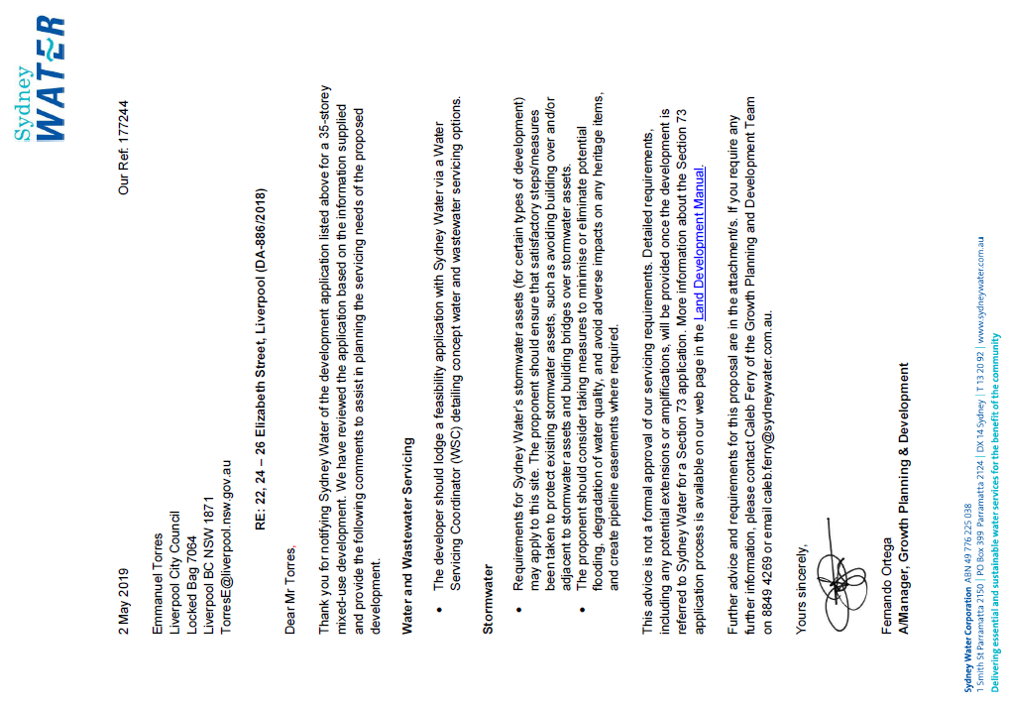
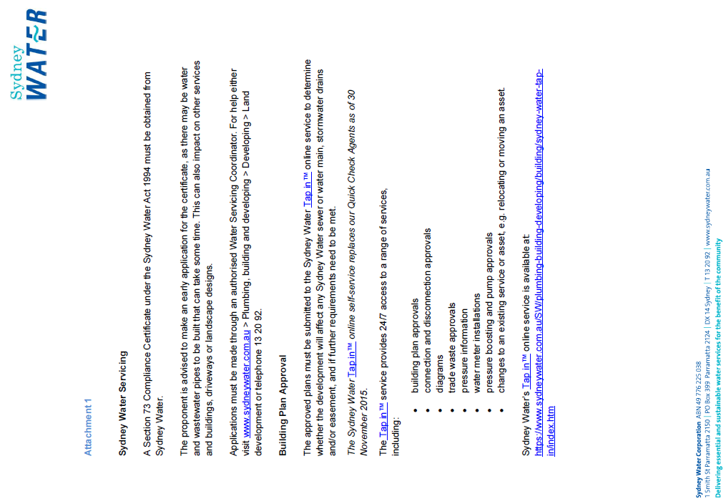
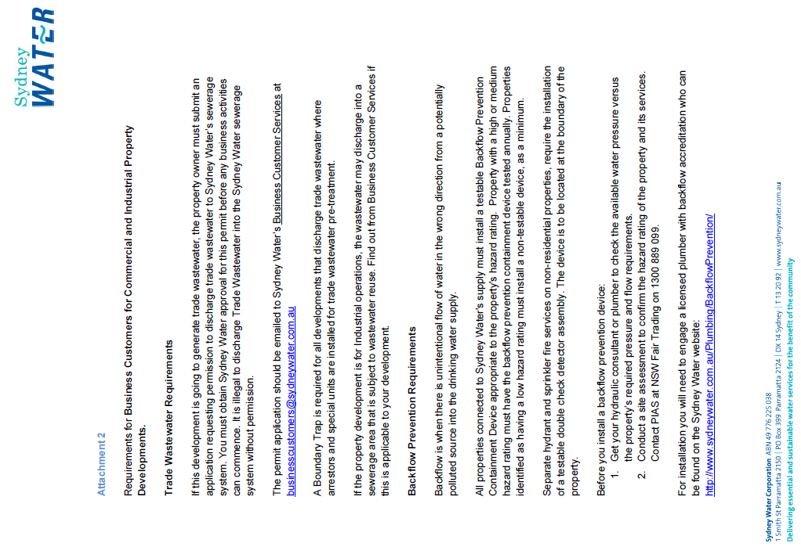
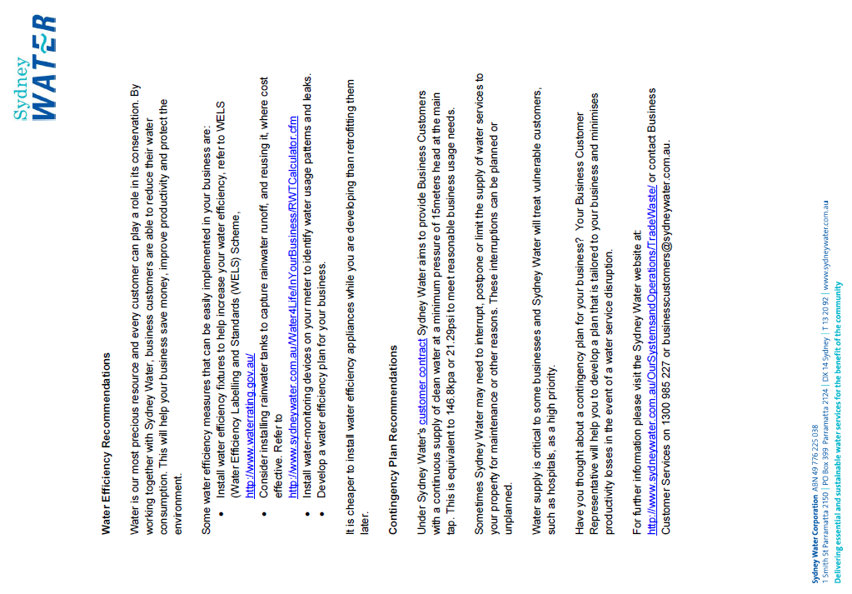
ATTACHMENT 4 - REQUIREMENTS OF ENDEAVOUR ENERGY
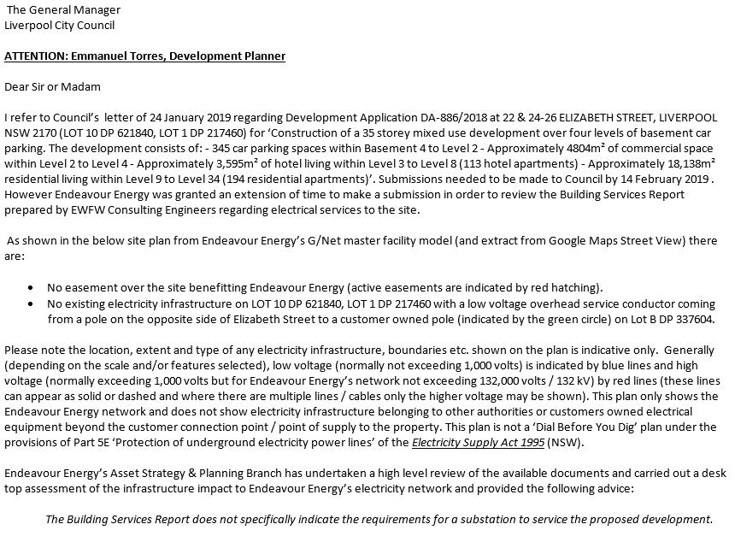
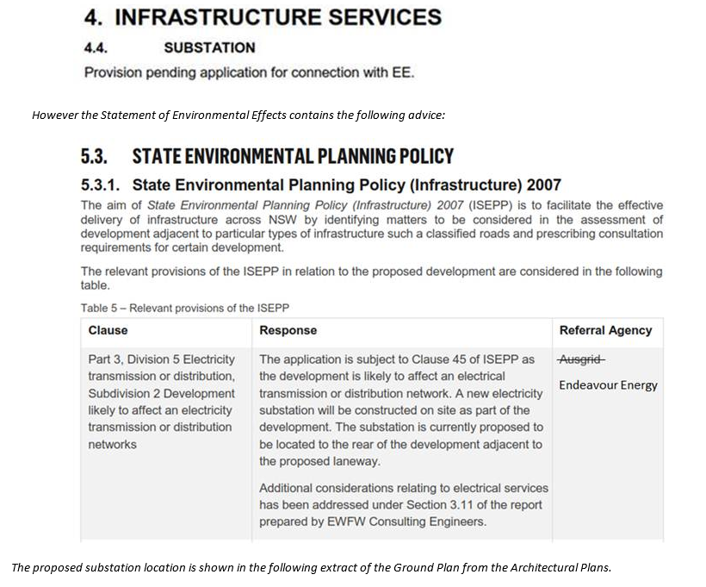
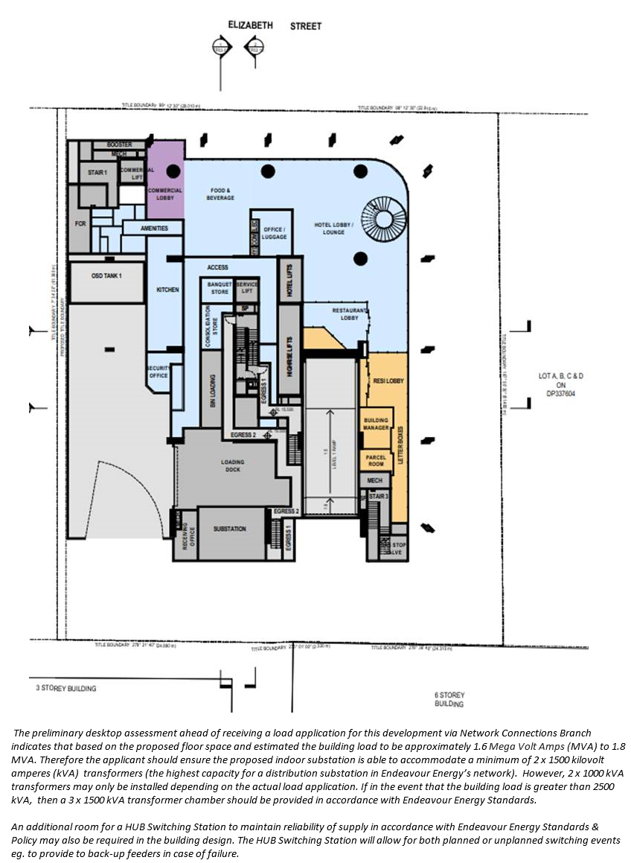
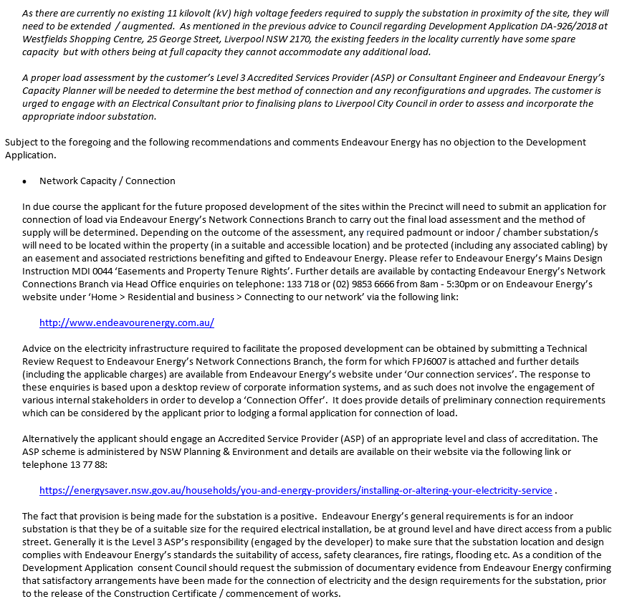
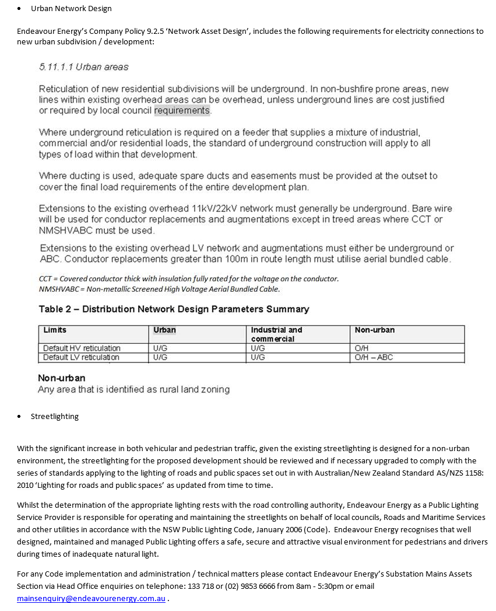
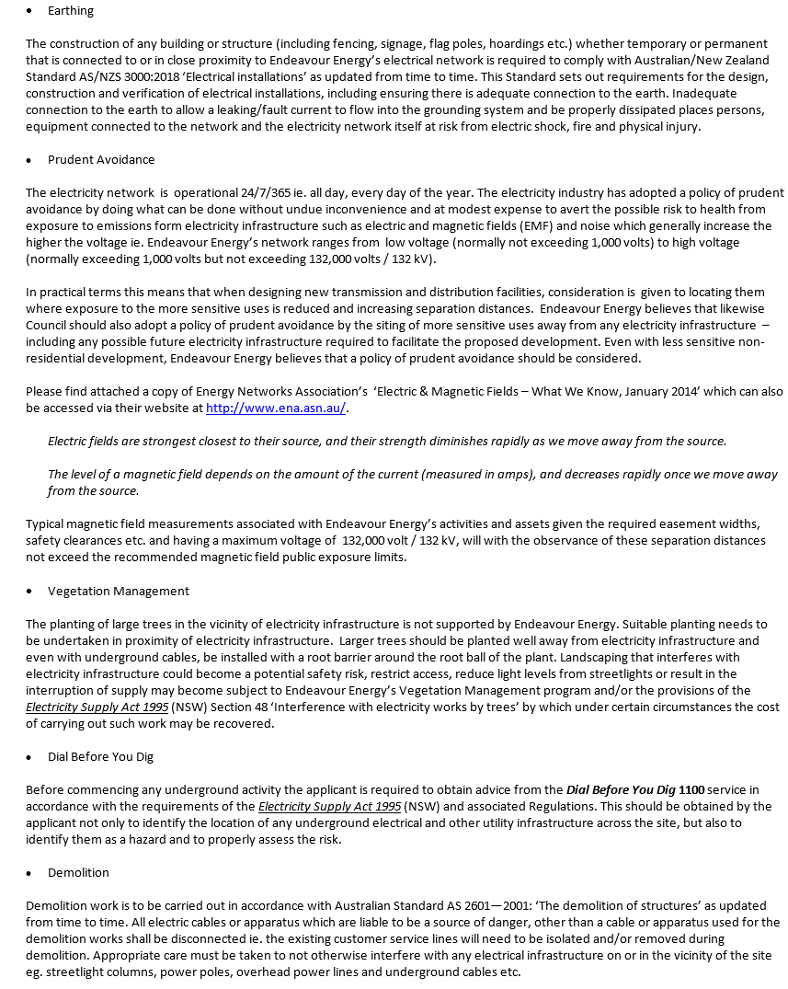
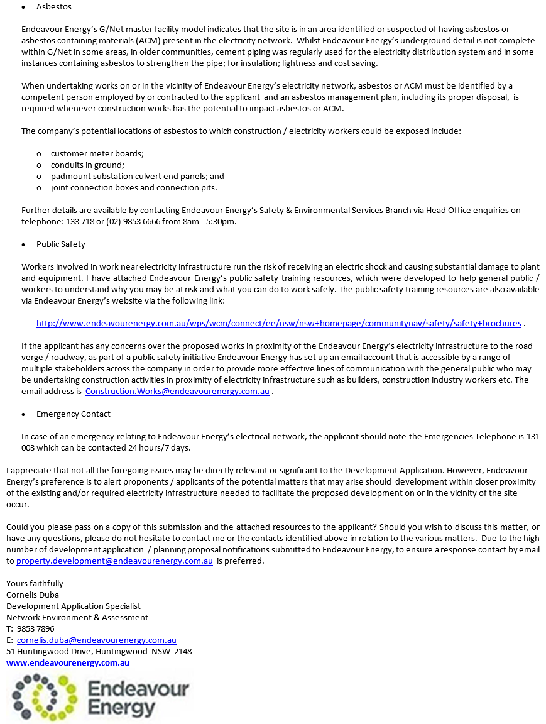
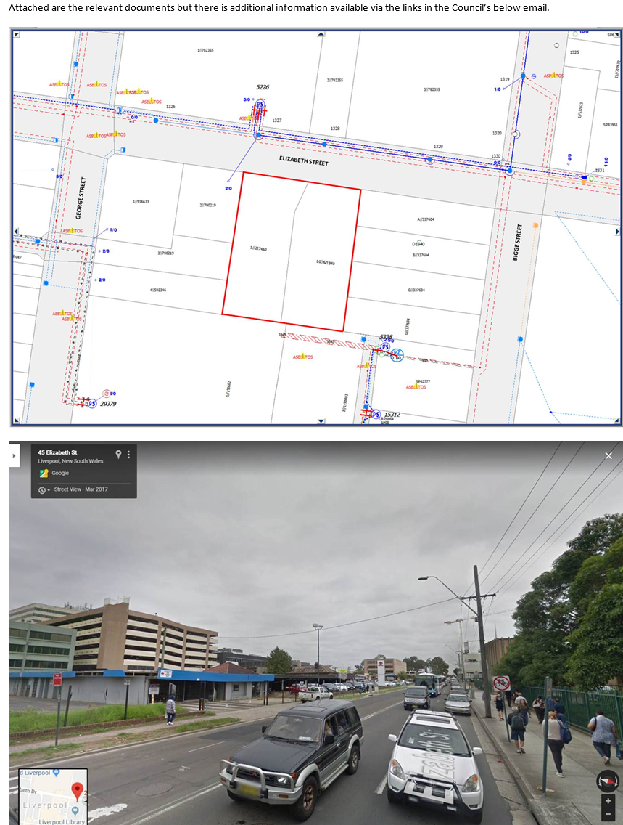

ATTACHMENT 5 - REQUIREMENTS OF THE DEPARTMENT OF INFRASTRUCTURE, TRANSPORT, CITIES AND REGIONAL DEVELOPMENT
